TEAM HEAT MAP ANALYSIS

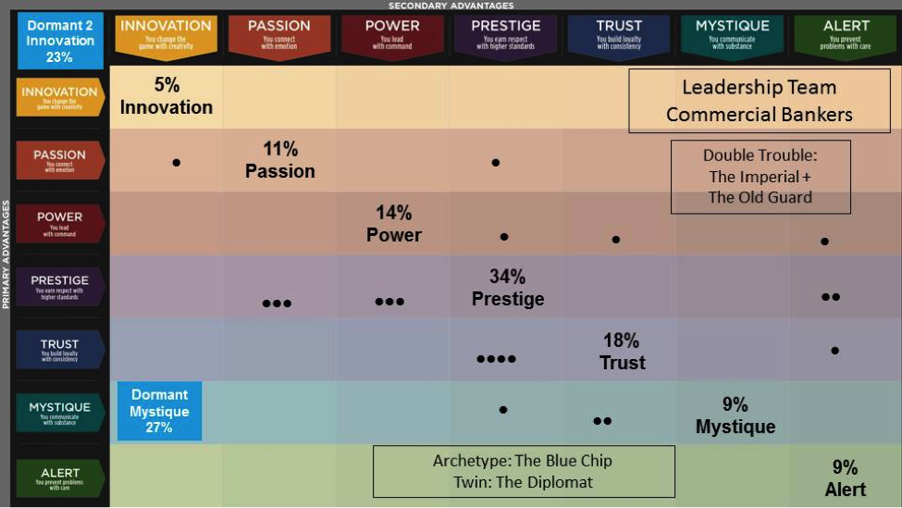

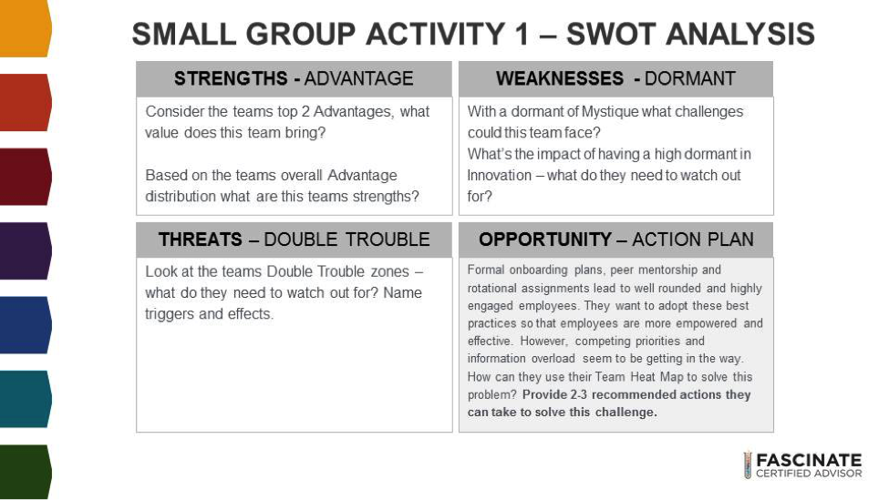

Amber and Andrea
- Create a PR plan (website/blog coverage, social media, community outreach/speaking opportunities) to promote onboarding and training program to external audience so that they will be internally motivated to fulfill the plan and live up to the expectation.
- Implement a 4DX or goal-driven meeting system with check-ins, problem solving and celebrations so they activate their lacking Alert, draw on their Prestige and Trust and create an opportunity for Innovation and Mystique to come out in a systematic way. Put an Alert personality in charge of scheduling, facilitating and implementation of ideas.
- Create an opportunity for competition against a common “enemy,” not each other. (e.g. Beat competitors for the area’s “Best Places to Work” Award

Gail and Toi
The Blue chip
Strengths-Advantage
· Common communication style
· Raise standards
· Quiet confidence
· Great presentation
· Eye for detail
· Stick to goals
· Earn respect

Dormant-Mystic
· Arrogant
· Cold
· Superior

1. Getting the team to adopt new initiatives by delegating project leads with team members who have passion as their primary advantage. Passion personality will leverage high energy to fire up the team to achieve a specific goal like adopting new ideas. Partner the passion project manager with prestige team lead to set higher standards. This will allow the overall trust capabilities of the team to do what they do best. Execute a safe dependable way.
2. Set measuring tools of excellent to speak to the overall prestige on the team. Select levels and images that will be associated with greatness for each level
· Good- if we adopt 1 new initiative good
· Great- if we adopt 5 new initiatives that great!
· Excellent! Why settle for being good when we can be great! adopt all new initiatives.
3. Provide clear direction on priorities of other task compared to this goal, this will minimize distraction.

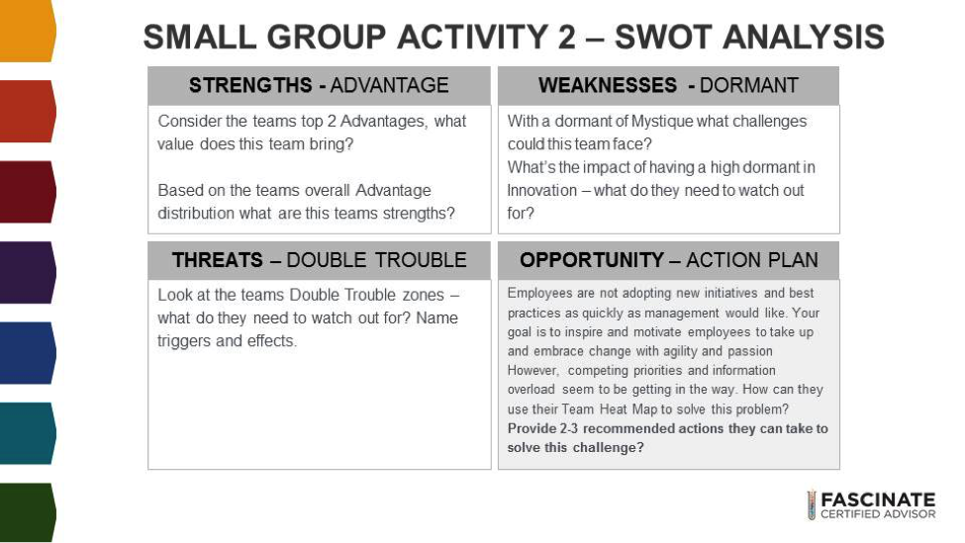

SCENARIO 2

Melissa and Tara
Strengths: Prestige (emphasis on excellence, respect, adding value through better process, paying attention to the smallest details) and Trust (building loyalty, consistency, dependable, stability, value routine, review details carefully)
Weakness: Innovation (you dislike situations that feel random, you don’t like surprises, when people behave inconsistently)
Threats: Imperial (arrogant, superior, too much focus on recognition can lead to these traits) and The Old Guard (predictable, safe, unwilling to change, being stuck in your own ways, resisting change in direction, takes a while to adjust)
Opportunities:
- Get innovation and alert to work together to review the suggested best practices / new ideas and visit with the other members of the team. Prestige could implement rewards / milestone awards (pizza party) for achievement of new goals.

Dorian and Joanne

Strengths: reliability, high standard, extremely smart, trustworthy, what you see is what they say,
Threats: superior tone, talk down, don’t give credit for the standard that people do manage to do, don’t give credit for what people know, can be inflexible, people should just get on with it
Weaknesses: being innovative relationally, not listening well, starting something brand new especially in the motivation area because they would want to convince standards and tried and true and logic, inspirational passion is not where they would naturally go, worry about emotions
Opportunity:
- Invite them to raise their overall standards to include more EQ into their thinking about how to resolve things. Provide them with researched data on how eq help in banking.
- Finding a way to bring the voices of those on the team that have Passion as a primary to share their views more to create the solution that might inspire the employees to change.
- Bring in an innovation guru to showcase some ideas and solutions that work
- Encourage them to listen to their employees’ to understand what is actually stopping the employees from taking on the new standards because of overload

