ACTIVITY 1
Use this time to get to know each other and...
Post your name, archetype and Fascinating Fact below:

Betty - The Archer, Mystique/Alert, I once touched Richard Simmons

Lauri -Rockstar, innovation/passion
I was a dancer for 15 years-performed tap, jazz, Hawaiian, ballet and pointe! I also sing!

Maria -

Jennifer -

Vivian - The Provocateur - Innovation/Mystique - I travel the world while inspiring others to live their writing dream.

Sarah - The Catalyst - Passion/Innovation - I’m adopted + reconnected with my biological families over the past few years - life altering. (Funny enough I help other people find/create their own identity as well as help them to be “different” both are things I’ve struggled with my whole life.)

Finka- The Trendesetter - Prestive + Innovation = City girl moved to the country 2 years ago and raising chickens :)

ACTIVITY 2
Fascinate Advantage Deep Dive

In your small group assign a:
· Scribe: Open Google Doc to capture your group’s notes
· Timekeeper: You have 15mins to complete this activity
· Speaker: Present your outcomes to the overall group

Support Material:
Participant Workbook: Page 7- 10
Resources and References Handbook:
– Primary Advantages: Page 11-17
– How Advantages Sell & Collaborate: Page 26
– How Advantages Take Action : Page 27
– How Advantages Team with others: Page 28-34

Advantage Deep Dive
1. What are key characteristics and value of this Advantage?
Group 2 (Sarah & Betty): Power and Alert

2. How does this Advantage drive us crazy?

ocollaboration among departments and insure the HardCell deal is sealed?

PASSION + MYSTIQUE = JENNIFER AND MARIA

POWER AND ALERT = SARAH AND BETTY

#1 -
Power: Confident, Goal-Oriented, and Decisive. The language of authority.
Alert: Perfectionistic, Reliable, Careful, Routine-oriented, Rational. Speaks language of Details.

#2 -
Power: Dominant, Overbearing, Dogmatic. “It’s my way or the highway.”
Alert: Compulsive, Driven, Exacting “Control Freak” - “Don’t touch my stuff- it’s perfection”

#3 -
Power: Tackle big goals, Self-assured in their actions and ideas, Can motivate/ inspire/ persuade large groups, Role model for how to behave.
Alert: Incites immediate action while keeping an eye on negative consequences
-Sensitive to others’ demands + expectations (almost anticipating them)
-Sets high expectations + establish structure that helps others follow-through.

TRUST + INNOVATION = LAURI AND VIVIAN

1)
Innovation:
Embraces change
Profound sense of adventure and creativity
Captivates with spontaneity
Values creativity and cutting edge
Attracts attention because of changing the game
Big picture thinker
Need space for your ideas

Trust:
Earns loyalty through dependability
Radiates a sincere warmth
Watches and reviews details carefully
Brings stability and calm to situations
Values routine and punctuality
Builds loyalty through consistency

2)
Innovation:
Chaotic, loves change which most people don’t.
Can be volatile when stressed.
Seems scattered, hard to keep focus for a long time.

Trust:
So stable and dependable that their is not a lot of creativity sometimes
Too dependant on others, so stable it’s annoying, nothing happens, too stand still
Too calm can also be annoying, want them to be engaged

3)
Innovation:
Think in a new and creative way, change it up
Do something spontaneous

Trust:
They will think of how to use something they are already doing
How to use what they already have

ACTIVITY 3
Anthem Builder
Objective:
● Build or validate your Anthem.
● Get hands on Anthem Building coaching practice.
Break out into assigned pairs.
○ 1 Person = Client + 1 Person = FCA.
○ Take turns to coach building an Anthem.
○ Anthem building (10 mins) + FCA coaching feedback (2 mins), then switch.
Coaching Options:
A) Build an Anthem
Complete Anthem Builder Worksheet Page 20-23
B) Validate an Anthem
Review your top speciality adjectives. Select 3 and reflect on how you`ve successfully demonstrated these. Page 15
Peak Performance – Share a story demonstrating your Anthem in action. Page 18
Support Material
● Bring your Anthem
● FCA Participant Workbook - Week One
● Fascinate Advantage Assessment
Your Anthem Statement:
“ My highest distinct value is my ability to deliver [your Anthem] .”
“If you need someone who delivers [your Anthem], I can help.”
“Even when things get tough, I promise to give [your Anthem].”

Anthems
Betty Anderson - Quiet Leader
Lauri Romano - Unorthodox Teamwork provider
Maria Hubbard -Proactive Solutions
Jennifer Giffen - Creative Thought Leadership
Vivian Songe - Inspirational Magic that guides you through your writing adventure.
Sarah Ancalmo - Intuitive Visionary - Creative Clarifier

ACTIVITY 4

TEAM HEAT MAP ANALYSIS

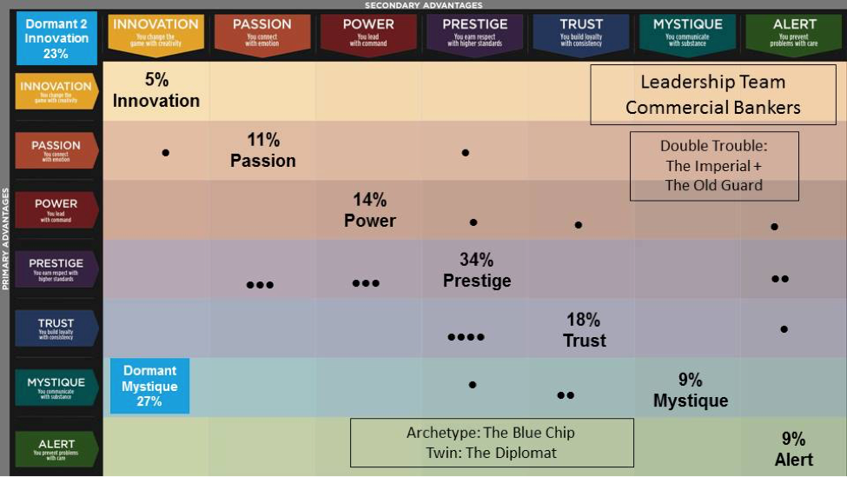

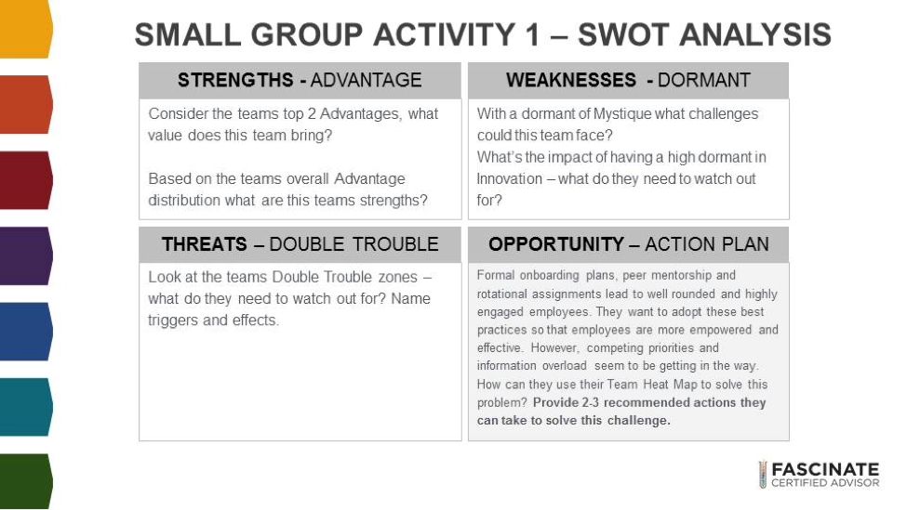

SCENARIO 1: Lauri, Sarah, Vivian

STRENGTHS :
The strengths are Prestige + Trust
Ambitious / high standards / consistent / stable / comforting / disciplined

WEAKNESSES :
Innovation + Mystique

THREATS : INFLEXIBLE / PRETENTIOUS / COLD
“RIGID, ROBOTIC” + “STODGY” + SELF CENTERED"
ACTION PLANS:
Formal onboarding plans, peer mentorship and rotational assignments lead to well rounded and highly engaged employees. They want to adopt these best practices so that employees are more empowered and effective. However, competing priorities and information overload seem to be getting in the way. How can they use their Team Heat Map to solve this problem? Provide 2-3 recommended actions they can take to solve this challenge.

Mystique + Innovation means they have great ideas but may be more quiet about speaking up - how can the onboarding process better encourage them to feel comfortable to speak up to the potentially more “stodgy” or “steadfast” majority of the group.
Get the passion + innovation people to step in in a larger way to help create the onboarding process.
Bring the new energy to balance out the steadfastness of the bulk of the team.
New ways to engage the others in the on boarding process.

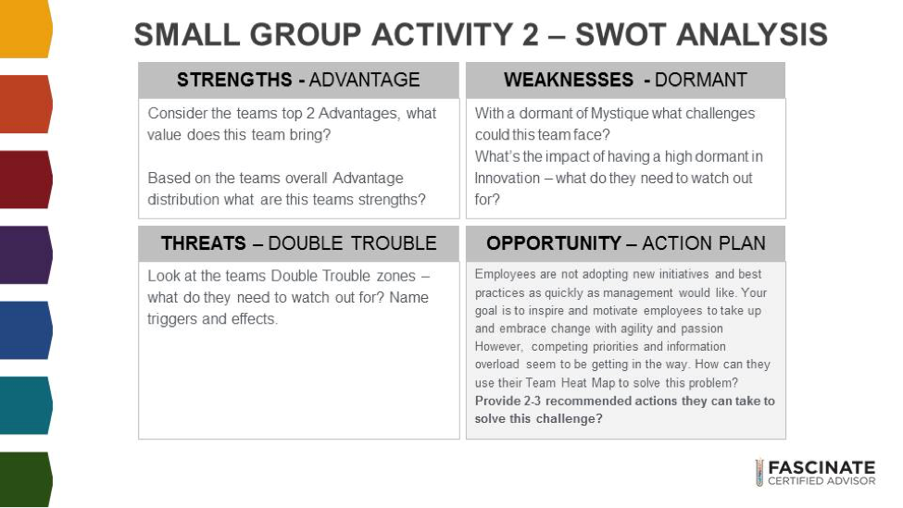

SCENARIO 2 - Maria, Jennifer, Betty

STRENGTHS : Prestige/ Trust (The Blue Chip)
- Classic, Established, Best in Class; language of excellence
- Quiet competence
WEAKNESSES : Mystique/ Innovation
- Not looking be constantly improving themselves - established and not looking to change
- Risk averse
- Slow to change; not nimble; not listening to other ideas

THREATS : DT: The Imperial (Arrogant, Cold, Superior) OR The Old Guard (Predictable, Safe, Unmoveable)
ACTION PLANS:
Employees are not adopting new initiatives and best practices as quickly as management would like. Your goal is to inspire and motivate employees to take up and embrace change with agility and passion However, competing priorities and information overload seem to be getting in the way. How can they use their Team Heat Map to solve this problemProvide 2-3 recommended actions they can take to solve this challenge?

- Assign Innovatives to monitor industry best practices (love excellence) and cutting edge activities
- Use Alert and Power folks to refocus priorities to those that have the best return on investment. Tie to Excellence motivator.
- Use Passion folks to make emotional appeal for the need to change.
- Appeal to Innovation folks to propose out-of-box solutions.

ACTIVITY 5

Activity Details
· Break out into 7 Advantage groups – assign speaker/scribe.
· Each group will be assigned 1 Advantage.
· Prepare a pitch for a prospective client using your assigned Advantages demonstrating how, How to Fascinate® is the perfect solution to their problem.
References
· Participant Workbook: Week 2, Page 38 - 41
· Advantage Communication Cheat Sheets on Page 45-51
Scenario
Your prospective client has been having issues with employee engagement due to numerous change initiatives. Employees are feeling disconnected from their work and team. Silos are forming and customers are starting to be impacted negatively. As an FCA you know that the HTF system can connect people back to their objectives, improve communication and ultimately get things back on track. You’re preparing to pitch your How to Fascinate® program to your client.
Sample using Prestige
You want to improve customer service, product quality, productivity and ultimately make more money. But things get in the way. In this competitive, fast paced and noisy world people get distracted from their goals and from what's really important. When this happens it impacts your company and results. Employees disconnect from their work and teams, silos form, conflicts emerge and customers get impacted. You want a team that`s connected to a common goal, working together collaboratively and cooperatively.
I can show you how the Fascinate system will improve employee engagement, build team collaboration and help you exceed your company goals. Your employee`s will be recognized for their unique Advantage and give you more of their best. Once you learn your Team Advantage you`ll recognize your team's strengths, identify hidden patterns and tap into your team's Advantages to become more productive and efficient.
Our clients have seen better than expected results, even those with world class employee engagement saw an increase in their scores after the How to Fascinate system was brought in. Fascinate has been delivered to organizations like Cisco, GE, ATT and Intel. Yes, it’s the newest and most innovative communication assessment out there – but it's one that's been built reputation on of trusted experts, principle and purpose.
Maria, Jennifer, Betty
Group 1 = Passion + Mystique + Trust
Passion:

Mystique:

Trust:

Lauri, Sarah, Vivian
Group 2 = Power + Alert + Innovation

Key Messages to Convey for each (pitch) think key words

Messaging to communicate to other advantages...

Power
This will change the game for you. It will help you stand out
Reach your goals.
Want to be shown certainty
Confidence in delivery
They want you to be Authorittative
Action oriented
Need to give them some power as well -
Being powerful in your arena but giving power in theirs.
Alert - language of details
Organized
Goal Oriented
Giving a lot of details
Practical
Detailed
Results (ask them about results / speak to)
Note structure

Innovation
Something is new
Pioneering/ progressive
Fun
Interesting
Trendy
Cutting Edge
Creative
Unique
Unexpected

