TEAM HEAT MAP ANALYSIS
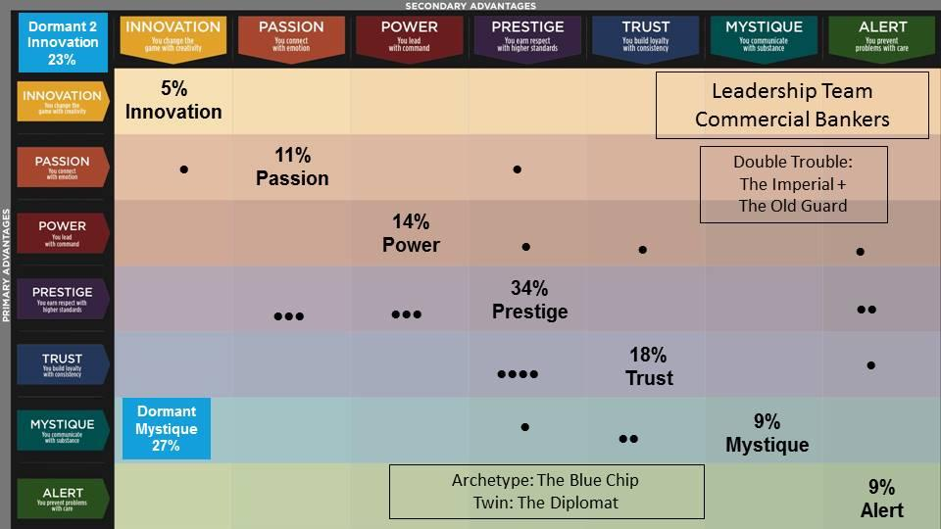

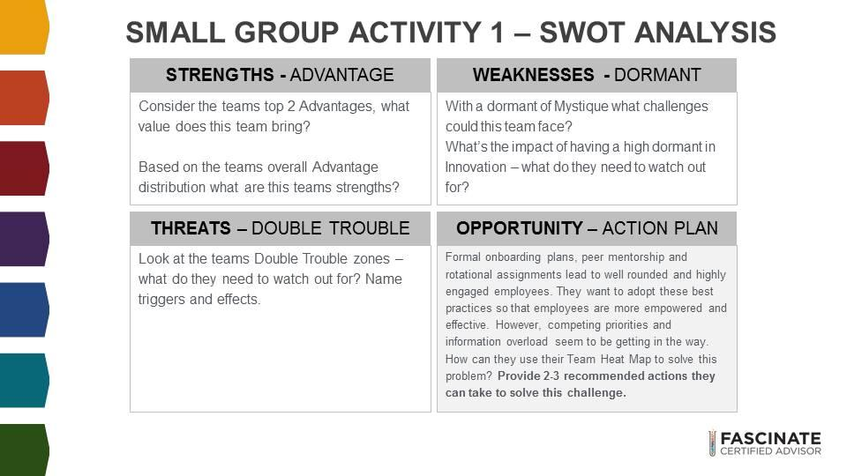
SCENARIO #1
Breakout Groups:
Michael & Ellen:
Strengths: Eye for detail, reputation for quiet excellence, dependable, experts, lead by example, level-headed, focus on team strengths instead of individual, strong work ethic.
Value = deliver impeccable best-in-class solutions
Weaknesses: Mystique: oversharing; consensus slows them down, Innovation: lacks originality/creativity. Perceived as boring.
Threats: (Double Trouble The Imperial/The Old Guard) Predictability; lack of innovation/creativity. Unmovable; slow to market (not a market leader). Superiority; emperor’s wearing no clothes. Focus too much on achievements and not visionary.
Opportunity:
Recommendation #1: Top down - set this project as a priority. Assign project leader - to help delegate tasks to team and move implementation forward.
Recommendation #2: Rely on your dependability and level-headedness to align as a team. Create structured plan and processes to get the project done.
Recommendation #3:

Tine & Gagan:
The value this team brings:
Prestige and Trust
They set high standards and earn respect in their areas. They are detail-oriented, and results-focused. They are best in class. They are classic and established.
They build loyalty with consistency. They are steady, focus on high quality and one thing at a time.
Weaknesses of this team:
Dormant Advantages: Mystique and Innovation
They lack communicating with substance. Surface-level conversations. Lack depth. Don’t ask deeper questions to underlying issues. Not good listeners. Don’t remain calm under pressure. Don’t bring their independent mindset to solve problems.
They are not creative folks. Don’t think outside the box. Not bold enough. Not eager to find new ways to solving problems. They are unable to work independently.
Treats of this team:
The Imperial (Prestige + Prestige) and The Old Guard (Trust + Trust):
The Imperial threats are: Arrogant, Cold, Superior, chip on their shoulders, They can intimidate others. They can be harsh and ruthless. They can be a cut-throat and barbaric. They could create this wall of “hard-to-get-to-know” them.
The Old Guard: Overly cautious, unmovable, stubborn, stuck and fixed-mindset. Very predictable. Boring, unenthusiastic. Risk-averse, back-ward thinking, or love the status-quo.

Opportunity: The Action Plan for this team.
We recommend:
Be good listeners. Sometimes, prestige can fail to communicate their high expectations and standards with others around them. Make sure they, as a team, slow down to touch base and be on the same page. Have an agenda.
Be independent thinkers and collaborate with others.
They are all great leaders and must motivate each other. (Power is their 3rd team advantage).

------------------------------------------------------------------------------------
SCENARIO #2
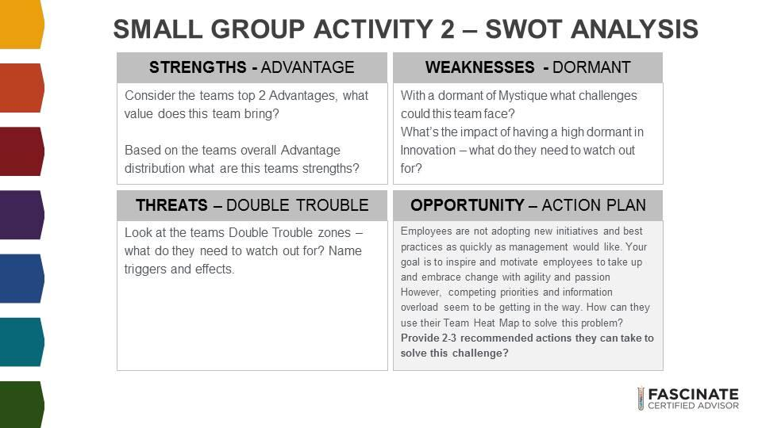

Breakout Groups:

Strengths:  Prestige and Trust = High quality results, high standards and consistency.  #3 is power = self confidence and authority. | Weakness:  Dormant Mystique: Lack of deeper understanding, not listening to their intuition, not understanding the problem. Being superficial.  Dormant Innovation: Not thinking outside the box, not leading with innovation, not offering the best solution, maintain status quo.
Threats:  The imperial: Overly competitive, Trust: Dull and out of date.  Guido’s understanding: If Trust value is challenged prestige value turns into double trouble => Overly competitive. When Prestige value is challenged Trust becomes the double trouble.  Tony’s understanding: When Prestige is overused as a strength the team becomes too competitive. When Trust is overused or under stress, the double trouble result is the team is dull and out of date. | Action Plan:  Prestige Don't: Make concessions or settle, don’t be just good enough, don’t accept things as they are, don’t rush decision making.  Prestige do: Focus on details, define new, higher standards, action plan, exceed expectations.  Trust Don’t: Don’t stir up conflict, don’t force change, don’t act unpredictably etc.  Trust Do: Build loyalty,  Bring in other advantages to balance heat map: Passion for communication, innovation for new ideas and power to drive decision making.

Tony & Guido

Robyn & Janelle
Strengths:
Prestige/Trust - highly collaborative nature, encouraging to the team. Focused and process-driven to deliver top-quality services
Double Trouble:
Can be overly competitive, come across as a know at all, and be dull and out of date with their products and service delivery.
Weakness -Dormant:
not prepared to think outside the box. Not open to new industry ideas, do not like to leave their comfort zone and not open change.
Action Plan:
- Motivate the team with goals and rewards attached
- When introducing new ideas, involve the use of a change management professional that can explain the outcomes, rationale, and benefits that the team will reap when they implement on these ideas.

